- In the below elements, which are values or an expression? E.g.: - values can be integers or strings and expressions will be mathematical operators.
Ans:
* : Mathematical operator (It is considered as a mathematical operator because it represents the multiplication operator when used in a mathematical context.)
'hello' : Strings. (A string is a collection of one or more characters put in a single quote, double-quote, or triple-quote. In Python there is no character data type, a character is a string of length one. It is represented by str class.)
-87.8 : Float. (It is a real number with a floating-point representation. It is specified by a decimal point.)
- : Mathematical operator (It is considered a mathematical operator because it represents a Subtraction operator when used in a mathematical context.)

/ : Mathematical operator (It is considered a mathematical operator because it represents a Division operator when used in a mathematical context.)
+ : Mathematical operator (It is considered a mathematical operator because it represents an Addition operator when used in a mathematical context.)
6 : Integers (This value is represented by int class. It contains positive or negative whole numbers (without fractions or decimals).
- What is the difference between string and variable?
Ans:
string | Variable
1. A string is a sequence of characters, typically enclosed in single or double quotes. Example: "Hello, World!" | 1. A variable is a symbolic name for a value or an object in a program. Example: my_variable = 8
2. String is a specific data type used to represent textual data. | 2. Variables can hold values of various data types, including strings, numbers, BOOLEAN, and more.
3. Strings are typically immutable, meaning their values cannot be changed once created. Operations on strings often create new strings | 3. Variables can hold different values at different times, so they are mutable
- Describe three different data types.
Ans:
Data Type | Description | Example
int | Integer data type represents whole numbers | 42
float | Floating-point data type represents decimals | 3.141
str | String data type represents text | “Hello, World”

- What is an expression made up of? What do all expressions do?
Ans:
Expression: An expression is a combination of operators, constants and variables. An expression may consist of one or more operands, and zero or more operators to produce a value.

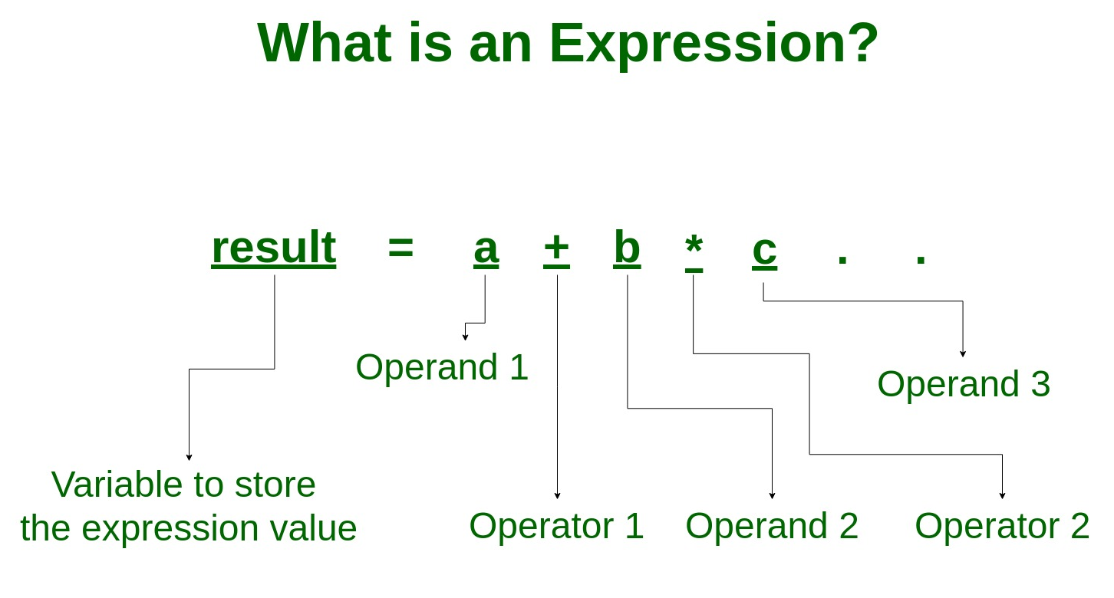
The all the Expression help to evaluate the solution of the Problem.
EXAMPLE:
# Multi-operator expression
a = 10 + 3 * 4 #print(a)
b = (10 + 3) * 4 #print(b)
c = 10 + (3 * 4) #print©

- This assignment statements, like spam = 10. What is the difference between an expression and a statement?
Ans:
1. Expression:
- An expression is a combination of operators and operands that evaluates to a single value.
- It can be as simple as a single value or a complex combination of values, operators, and function calls.
- Examples of expressions include `2 + 3`, “x * y”, and len("Hello").

2. Statement:
- A statement is a complete line of code that performs an action, task, or operation.
- Statements are executed sequentially in a program and can include assignments, loops, conditionals, function definitions, and more.
- Unlike expressions, statements do not produce a value (or the value they produce is `None`).
- Examples of statements include variable assignments like `spam = 10`, conditional statements like “if x > 5:”, and loops like “for item in my_list:”.

In the case of the assignment statement “spam = 10”, it is a statement because it doesn't produce a value but rather assigns the value “10” to the variable “spam”. You can't use this statement as part of a larger expression, but you can use the value of “spam” in expressions after the assignment.

Here's an example that illustrates the difference:

## python
x = 5 # Assignment statement, no value produced
y = 3
result = x + y # Expression, produces a value
print(result) # Output: 8
In this code snippet, x = 5 and y = 3 are assignment statements, while x + y is an expression that produces the value “8”, which is then assigned to the variable “result”.
6. After running the following code, what does the variable bacon contain?
bacon = 22
bacon + 1
Ans: The variable bacon will still contain the value 22.
In the second line, bacon + 1 is an expression that adds 1 to the value of bacon, but the result of this expression is not assigned to any variable, so it does not modify the value of bacon. If you want to update the value of bacon, you should assign the result of the expression back to the bacon variable like this:
bacon = bacon + 1
After this assignment, bacon would contain 23.

7. What should the values of the following two terms be?
'spam' + 'spamspam'
'spam' * 3
Ans:
1. ”spam”+ “spamspam”: This concatenates the two strings together, resulting in `”spamspamspam”.
2. ”spam”* 3 : This multiplies the string ”spam” by 3, repeating it three times, resulting in “spamspamspam”.
So, both expressions produce the same value, which is “spamspamspam”.

- Why is eggs a valid variable name while 100 is invalid?
Ans:In Python, variable names must adhere to certain rules and conventions. Here's why 'eggs' is a valid variable name while '100' is invalid:
1. Starts with a letter or underscore: Variable names must start with a letter (a-z, A-Z) or an underscore (_). Therefore, 'eggs' starts with a letter and is a valid variable name.
2. Followed by letters, digits, or underscores: After the first character, variable names can consist of letters, digits (0-9), or underscores. So, 'eggs' consists of letters only, which is valid.
Now, let's consider '100':
1. '100' starts with a digit ('1'). Variable names cannot start with a digit, as it violates the rule of starting with a letter or underscore.
2. While '100' consists of digits, it doesn't start with a valid character, so it's an invalid variable name.
To summarize, variable names in Python must follow specific rules, including starting with a letter or underscore and containing only letters, digits, or underscores after the first character. 'eggs' adheres to these rules, while '100' does not because it starts with a digit.

- What three functions can be used to get the integer, floating-point number, or string version of a value?
Ans: In Python, you can use the following three functions to convert a value to an integer, a floating-point number, or a string:
- To get the integer version of a value:- You can use the `int()` function. This function tries to convert a given value into an integer. If the value is a floating-point number, it truncates the decimal part. If the value is a string that represents a valid integer, it converts it to an integer.
- Example:
“””#python
value = 42.7
integer_value = int(value) # Converts 42.7 to 42”””
- To get the floating-point number version of a value: - You can use the `float()` function. This function converts a given value to a floating-point number. It can convert integers, strings representing floating-point numbers, and other numeric types to floating-point numbers. Example:
“””#python
value = "3.14159"
float_value = float(value) # Converts the string to a float: 3.14159“””.
3. To get the string version of a value:- You can use the `str()` function. This function converts a given value into its string representation. It can be used to convert numbers, booleans, or other data types to strings. Example:
“””#python
value = 42
string_value = str(value) # Converts the integer to a string: "42" “””
10. Why does this expression cause an error? How can you fix it?
'I have eaten ' + 99 + ' burritos.'
Ans:
The expression “I have eaten” + 99 + “ burritos.” causes an error because you are attempting to concatenate a string with an integer directly. In Python, you can concatenate strings using the `+` operator, but you cannot concatenate a string directly with an integer.
To fix this error, you need to convert the integer `99` to a string before concatenating it with the other strings. You can do this using the `str()` function like so:
```#python
'I have eaten ' + str(99) + ' burritos.'
```
This way, the integer `99` is converted to its string representation before being concatenated with the other strings, and you won't encounter an error. The resulting string will be `'I have eaten 99 burritos.'`.

